**Filtro HP Chebyshev II**

|  |  |
| --- | --- |
| **Quantizado 18 bits Forma direta II Second-Order Sections** | |
| --------------------------  Section #1  --------------------------  Quantized Numerator:  1  -1.743682861328125  1  Quantized Denominator:  1  0.0469818115234375  0.033966064453125  Quantized Gain:  0.055919647216796875  --------------------------  Section #2  --------------------------  Quantized Numerator:  1  -0.6473388671875  1  Quantized Denominator:  1  0.270782470703125  0.2782135009765625  Quantized Gain:  1  --------------------------  Section #3  --------------------------  Quantized Numerator:  1  -0.0477447509765625  1  Quantized Denominator:  1  0.559326171875  0.70068359375  Quantized Gain:  1  --------------------------  Quantized Output Gain:  1 | --------------------------  Section #1  --------------------------  Reference Numerator:  1  -1.743686963462730998841720975178759545088  1.00000000000000244249065417534438893199  Reference Denominator:  1  0.046977649446981281644575290101784048602  0.033971985213526512126236411859281361103  Reference Gain:  0.055919647216796875  --------------------------  Section #2  --------------------------  Reference Numerator:  1  -0.647343803458644284631873233593069016933  0.999999999999998001598555674718227237463  Reference Denominator:  1  0.270775864304702851281803077654330991209  0.278206667200348367607887212216155603528  Reference Gain:  1  --------------------------  Section #3  --------------------------  Reference Numerator:  1  -0.047744047185999616278451185280573554337  1.000000000000002886579864025407005101442  Reference Denominator:  1  0.559321681560814631950506736757233738899  0.700682609789414101442162063904106616974  Reference Gain:  1  --------------------------  Reference Output Gain:  1 |

|  |  |
| --- | --- |
| **Comparativo** | |
| Discrete-Time IIR Filter (real)  -------------------------------  Filter Structure : Direct-Form II  Numerator Length : 7  Denominator Length : 7  Stable : Yes  Linear Phase : No  Arithmetic : fixed  Numerator : s18,18 -> [-5.000000e-01 5.000000e-01)  Denominator : s18,16 -> [-2 2)  Input : s16,15 -> [-1 1)  Output : s16,12 -> [-8 8)  State : s16,15 -> [-1 1)  Numerator Prod : s34,33 -> [-1 1)  Denominator Prod : s34,31 -> [-4 4)  Numerator Accum : s40,33 -> [-64 64)  Denominator Accum : s40,31 -> [-256 256)  Round Mode : convergent  Overflow Mode : wrap  Cast Before Sum : true    Implementation Cost  Number of Multipliers : 13  Number of Adders : 12  Number of States : 6  Multiplications per Input Sample : 13  Additions per Input Sample : 12 | Discrete-Time IIR Filter (real)  -------------------------------  Filter Structure : Direct-Form II, Second-Order Sections  Number of Sections : 3  Stable : Yes  Linear Phase : No  Arithmetic : fixed  Numerator : s18,16 -> [-2 2)  Denominator : s18,16 -> [-2 2)  Scale Values : s18,21 -> [-6.250000e-02 6.250000e-02)  Input : s16,15 -> [-1 1)  Section Input : s16,14 -> [-2 2)  Section Output : s16,11 -> [-16 16)  Output : s16,11 -> [-16 16)  State : s16,15 -> [-1 1)  Numerator Prod : s34,31 -> [-4 4)  Denominator Prod : s34,31 -> [-4 4)  Numerator Accum : s40,31 -> [-256 256)  Denominator Accum : s40,31 -> [-256 256)  Round Mode : convergent  Overflow Mode : wrap  Cast Before Sum : true    Implementation Cost  Number of Multipliers : 13  Number of Adders : 12  Number of States : 6  Multiplications per Input Sample : 13  Additions per Input Sample : 12  Multiplications per Input Sample : 15  Additions per Input Sample : 14 |

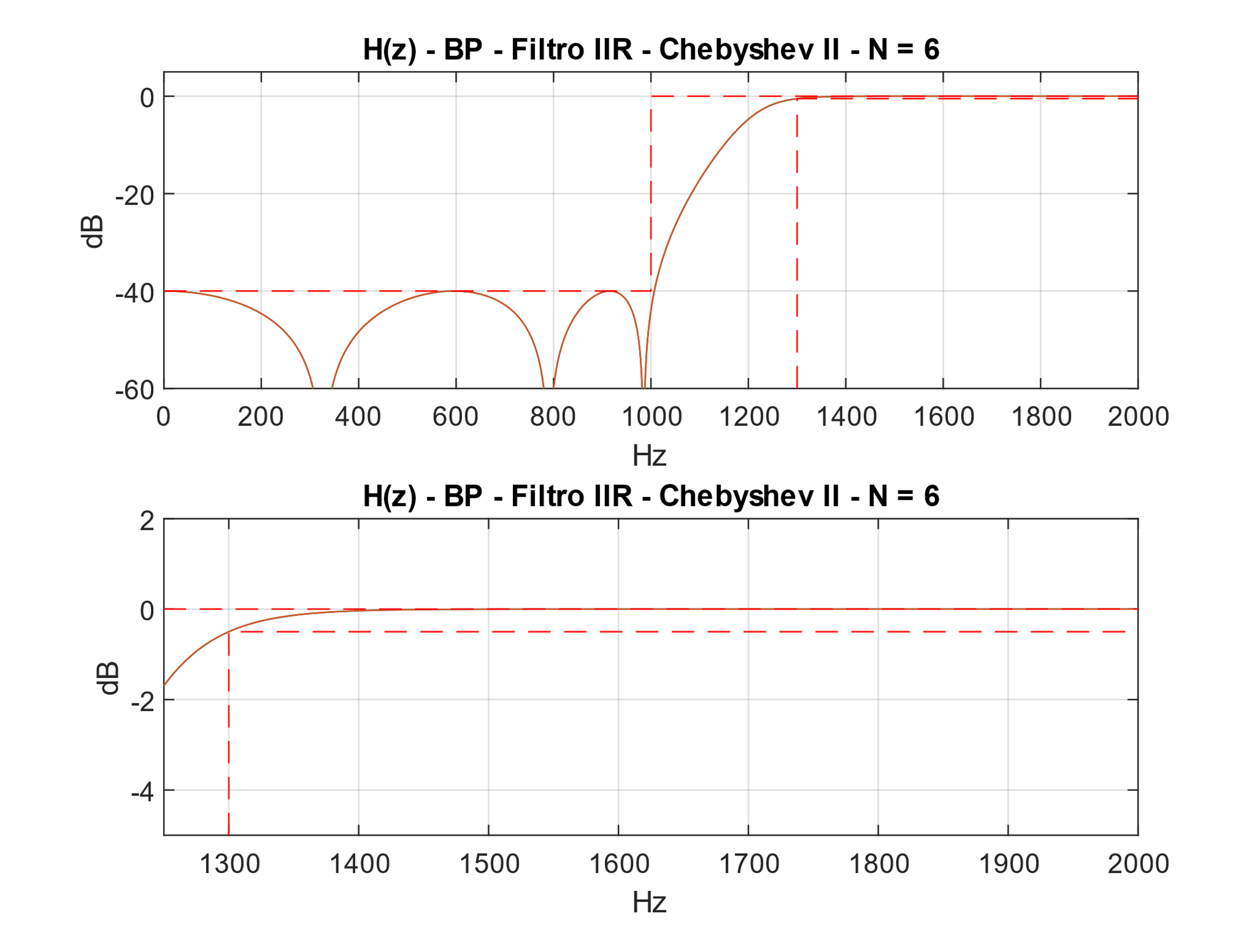

Figura - Filtro DFII

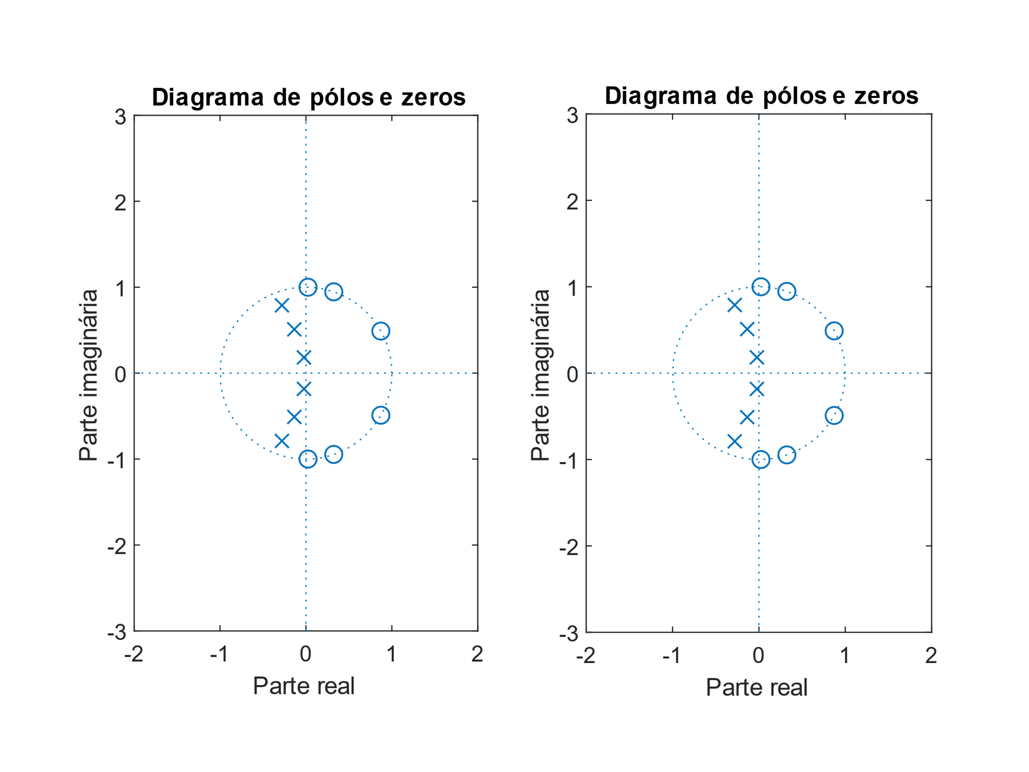

Figura - Filtro DFII

ASIC:

(2M + S + D) * nº bits

(2 * 13 + 12 + 6) * 18 = 792 elementos

FPGA:

(2M + S) * nº bits

(2 * 13 + 12) * 18 = 684 elementos

**Filtro HP Hann**

|  |  |
| --- | --- |
| **Quantized Numerator 8bits** | **Reference Numerator** |
| 0  0  0.0009765625  -0.0009765625  -0.001953125  0.0048828125  0  -0.009765625  0.0068359375  0.013671875  -0.0205078125  -0.0087890625  0.0400390625  -0.0126953125  -0.0615234375  0.0693359375  0.0771484375  -0.302734375  0.4130859375  -0.302734375  0.0771484375  0.0693359375  -0.0615234375  -0.0126953125  0.0400390625  -0.0087890625  -0.0205078125  0.013671875  0.0068359375  -0.009765625  0  0.0048828125  -0.001953125  -0.0009765625  0.0009765625  0  0 | -0.000031622870030890501825797389567895834  0.000065862100614956376322221831554060145  0.000776097424594572832083627655919144672  -0.001231907266215328828479202982748574868  -0.001660484294847263840241846644119050325  0.004721507755624553166751145028001701576  0.000207579074215400968036332463029225437  -0.00988656701538323350042514192637099768  0.006615692020637488519885227589156784234  0.013228130452963580976355473239891580306  -0.020494791768223590694431024417099251878  -0.008527326718309814410079461310942861019  0.040174116896658021436117280700273113325  -0.012988367104867398413303725135392596712  -0.061213776255290390515551024464002694003  0.069317230510543628718700404078845167533  0.077451071923706094057848758893669582903  -0.303130389651806941841982734331395477057  0.413280930834306503562913803762057796121  -0.303130389651806941841982734331395477057  0.077451071923706094057848758893669582903  0.069317230510543628718700404078845167533  -0.061213776255290390515551024464002694003  -0.012988367104867398413303725135392596712  0.040174116896658021436117280700273113325  -0.008527326718309814410079461310942861019  -0.020494791768223590694431024417099251878  0.013228130452963580976355473239891580306  0.006615692020637488519885227589156784234  -0.00988656701538323350042514192637099768  0.000207579074215400968036332463029225437  0.004721507755624553166751145028001701576  -0.001660484294847263840241846644119050325  -0.001231907266215328828479202982748574868  0.000776097424594572832083627655919144672  0.000065862100614956376322221831554060145  -0.000031622870030890501825797389567895834 |

|  |  |
| --- | --- |
| **Comparativo** | |
| Discrete-Time FIR Filter (real)  -------------------------------  Filter Structure: Direct-Form Symmetric FIR  Filter Length : 37  Stable : Yes  Linear Phase : Yes (Type 1)  Arithmetic : fixed  Numerator : s10,10 -> [-5.000000e-01 5.000000e-01)  Input : s16,15 -> [-1 1)  Filter Internals: Full Precision  Output : s27,25 -> [-2 2) (auto determined)  Tap Sum : s17,15 -> [-2 2) (auto determined)  Product : s26,25 -> [-1 1) (auto determined)  Accumulator : s27,25 -> [-2 2) (auto determined)  Round Mode : No rounding  Overflow Mode : No overflow    Implementation Cost  Number of Multipliers : 19  Number of Adders : 37  Number of States : 36  Multiplications per Input Sample: 19  Additions per Input Sample : 37 | Discrete-Time FIR Filter (real)  -------------------------------  Filter Structure : Direct-Form FIR Transposed  Filter Length : 37  Stable : Yes  Linear Phase : Yes (Type 1)  Arithmetic : fixed  Numerator : s10,10 -> [-5.000000e-01 5.000000e-01)  Input : s16,15 -> [-1 1)  Filter Internals : Full Precision  Output : s27,25 -> [-2 2) (auto determined)  States : s27,25 -> [-2 2) (auto determined)  Product : s25,25 -> [-5.000000e-01 5.000000e-01) (auto determined)  Accumulator : s27,25 -> [-2 2) (auto determined)  Round Mode : No rounding  Overflow Mode : No overflow    Implementation Cost  Number of Multipliers : 37  Number of Adders : 36  Number of States : 36  Multiplications per Input Sample : 37  Additions per Input Sample : 36 |

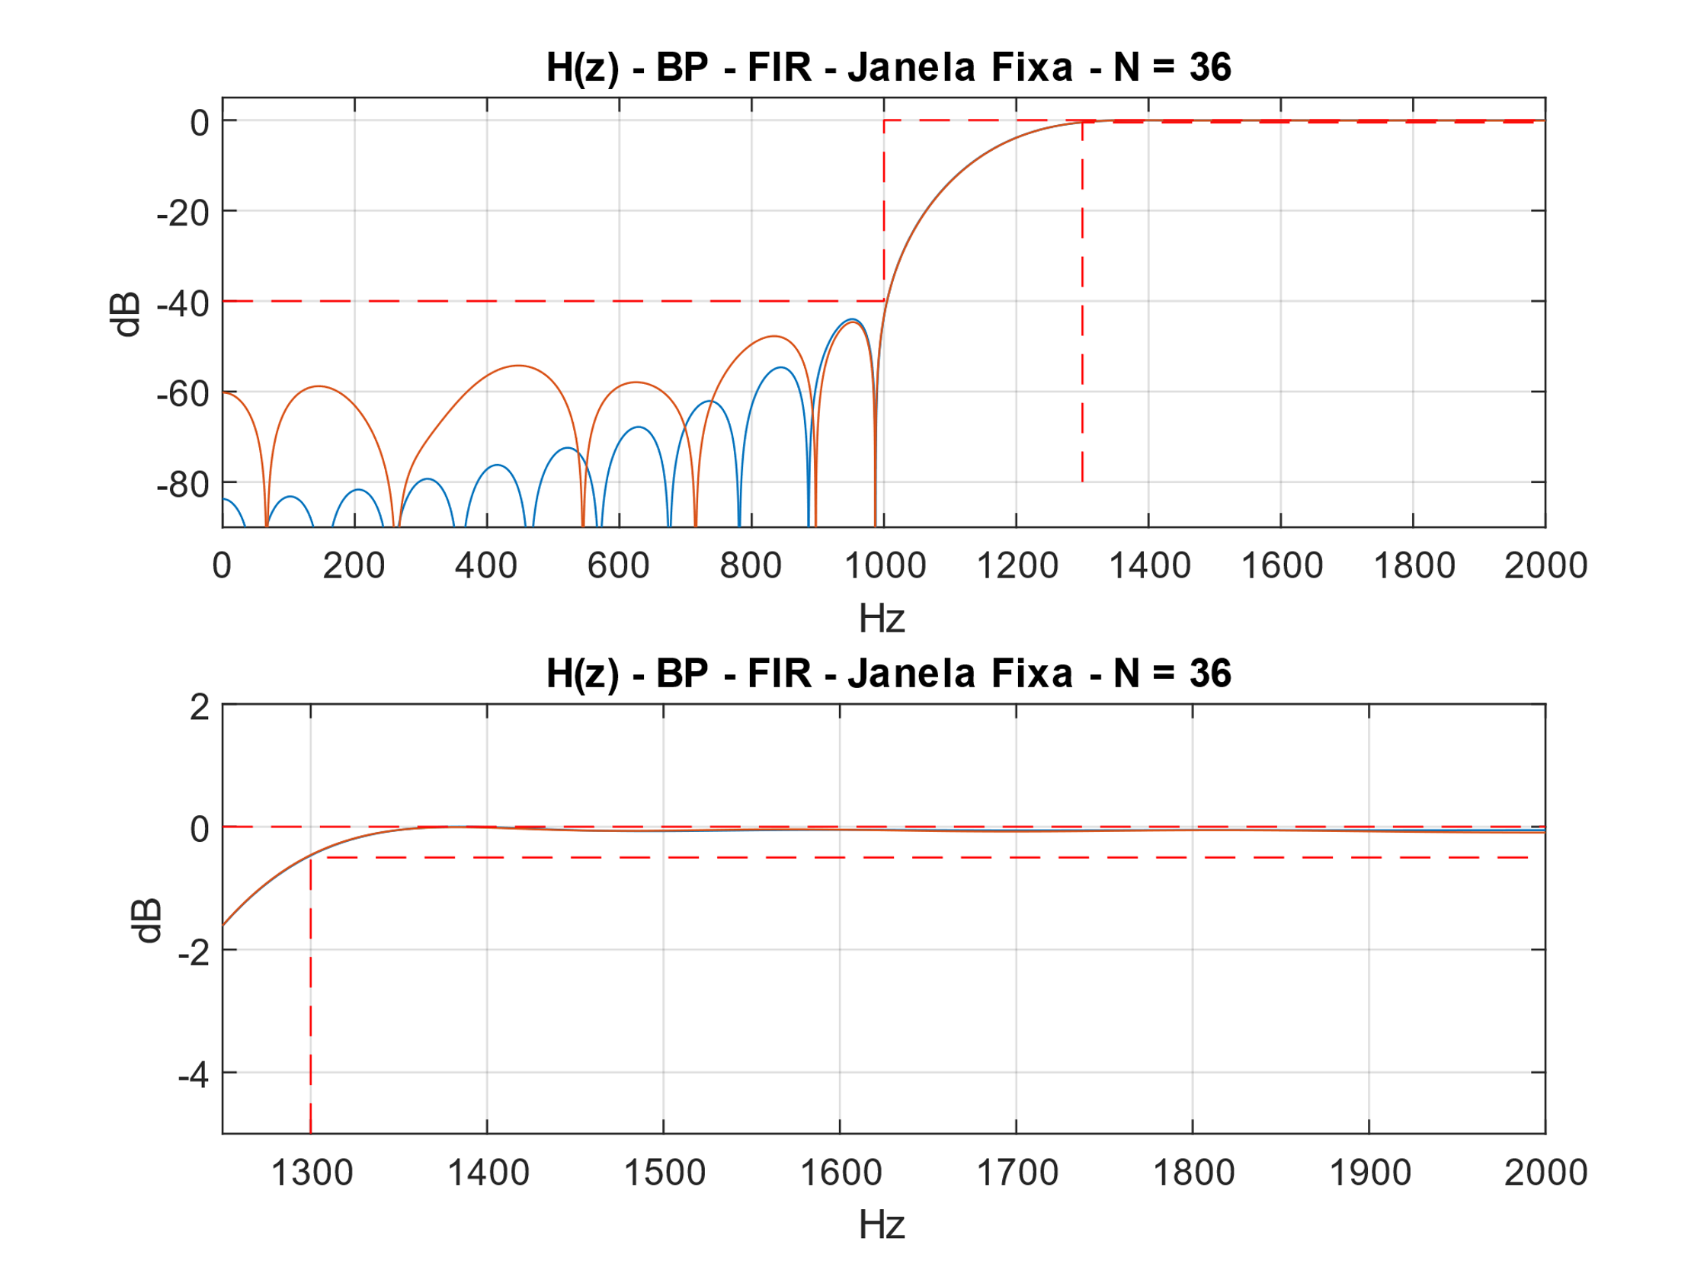

Figura - Filtro DF Symmetric.

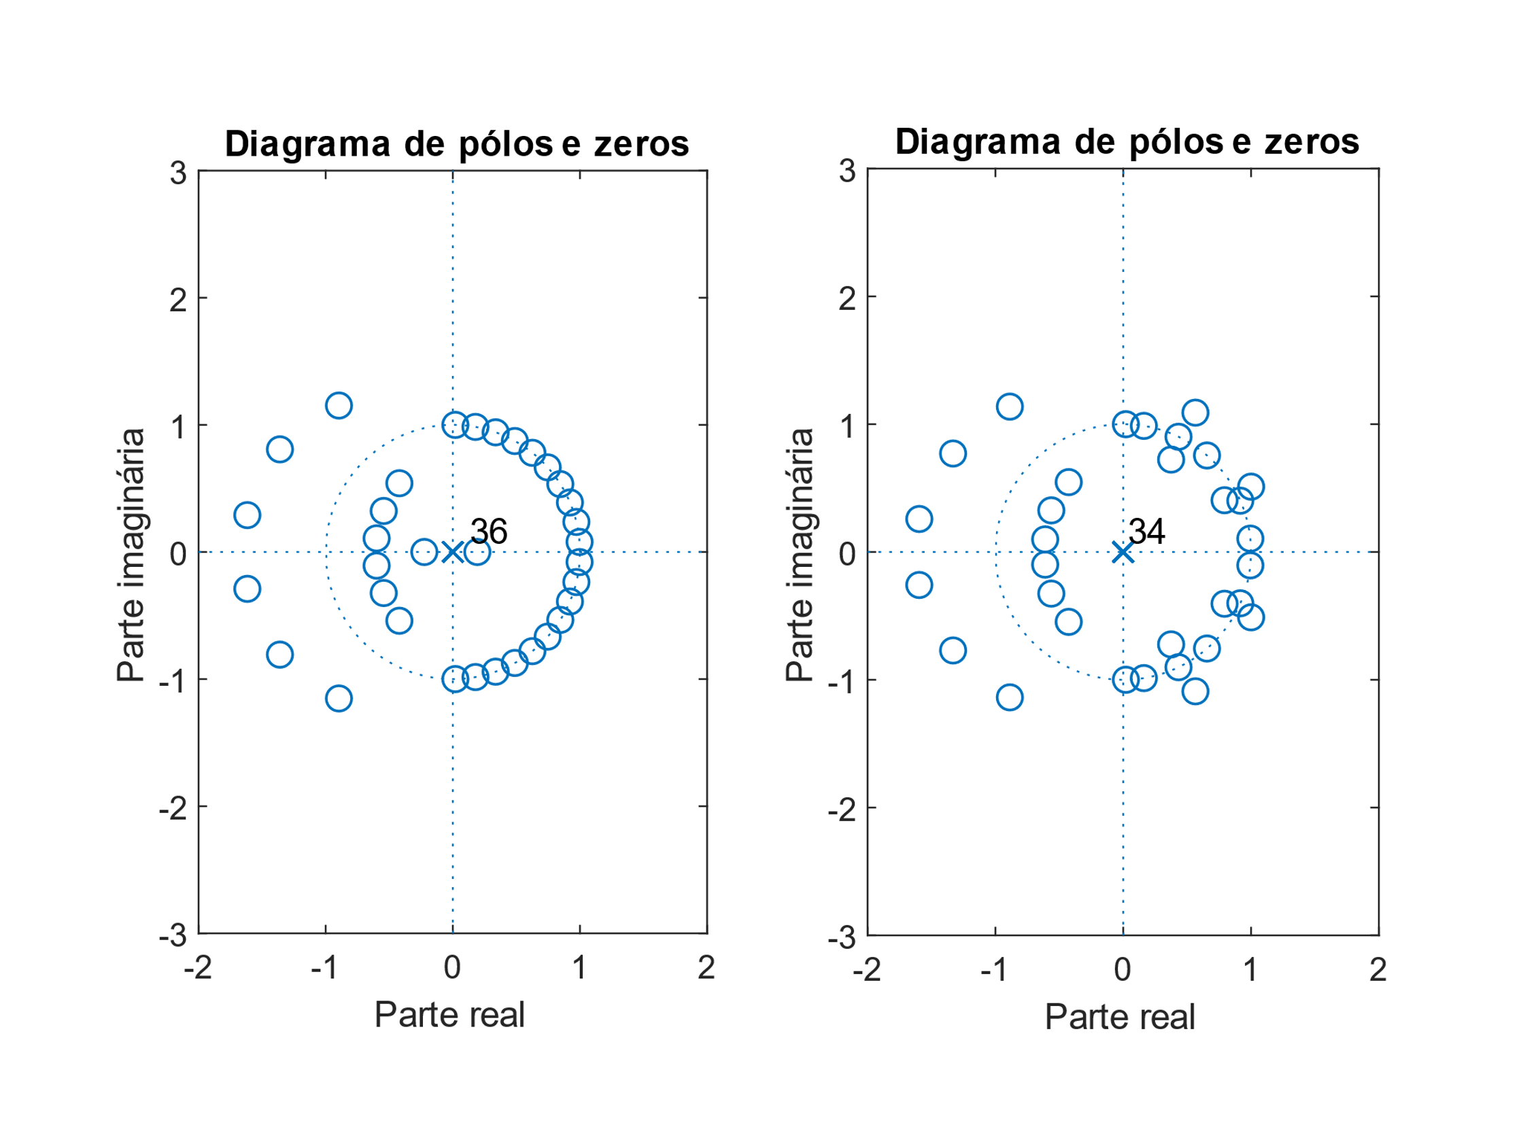

Figura - Filtro DF Symmetric.

ASIC:

(2M + S + D) * nº bits

(2 * 19 + 37 + 36) * 10 = 1110 elementos

FPGA:

(2M + S) * nº bits

(2 * 19 + 37) * 10 = 750 elementos